# Chapter 2: Kinematics

**All Lectures Uploaded on Youtube:**

[**https://tinyurl.com/fkm9-physics**](https://tinyurl.com/fkm9-physics)



**Mechanics:** The branch of Physics that looks into motion with/without reference to forces.

**Kinematics:** It is the sub-branch of Physics that describes motions of objects and bodies without considering the forces that cause them.

**Rest:** Object/Person isn’t moving with respect to the observer.

**Motion:** Object/Person is moving with respect to the observer. Types of motions:

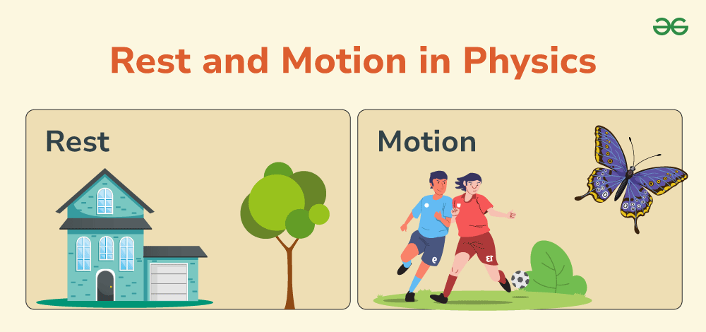

**Translatory Motion:** Motion in which all points of a moving body move uniformly in the same direction. (Up, Down, Left, Right, Front, Back).

1. **Rectilinear:** Translatory motion that occurs in a straight line (one direction only).
2. **Curvilinear:** Translatory motion when an object moves in a curved / circular path.
3. **Irregular:** Translatory motion when an object has no specific path. (Random motion)

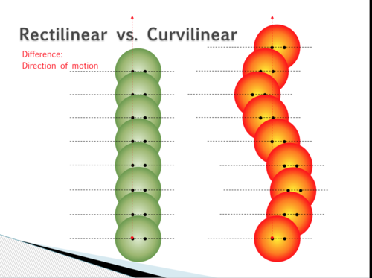

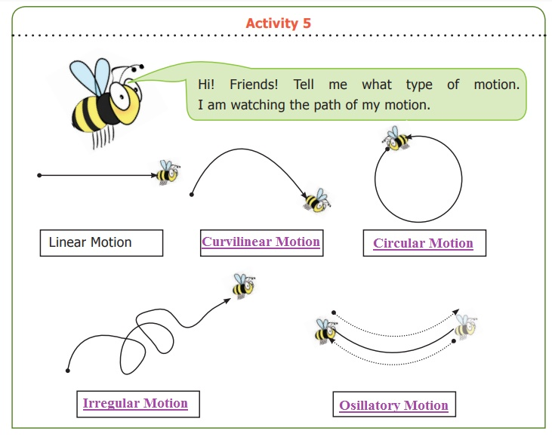

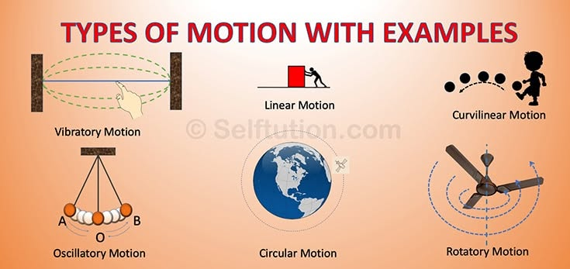

**Rotatory Motion:** All points of a body maintain a constant distance and rotate in circular paths about an axis. (Spinning around)

**Vibratory Motion:** Periodic back-and-forth movement of a body repeatedly about a mean position.

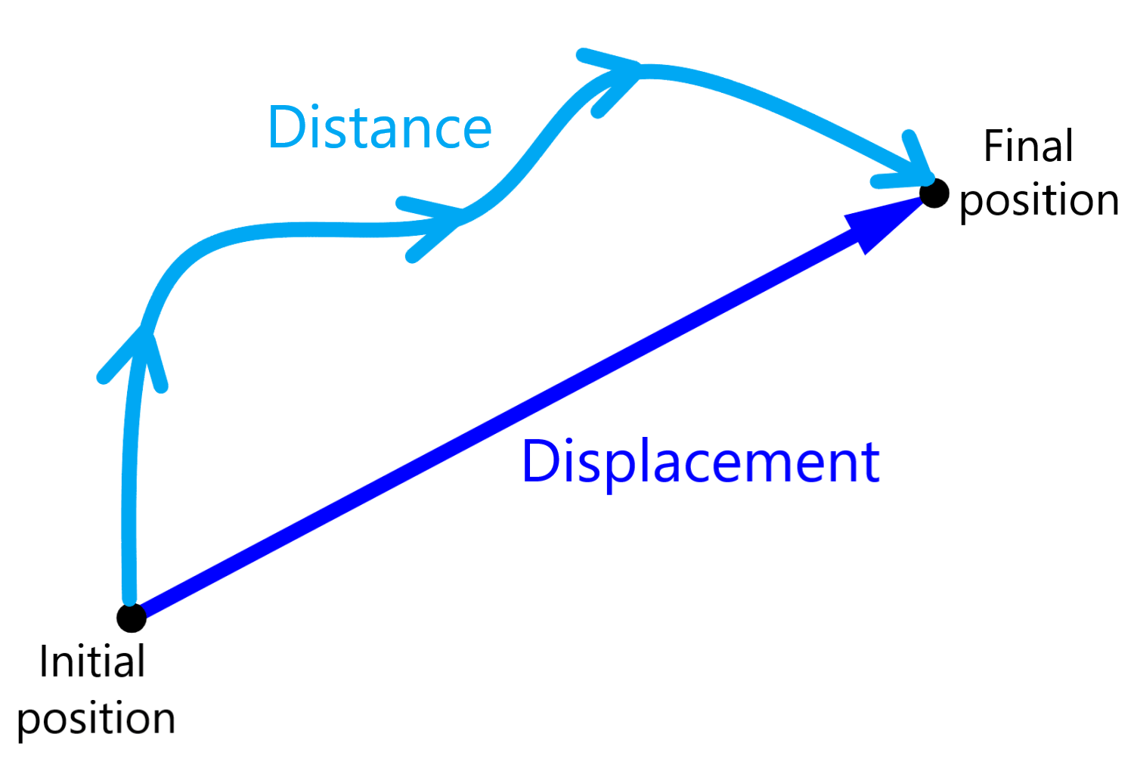

**Distance:** Length of path travelled between two locations/positions.

**Displacement:** The shortest distance between two locations/positions.

**Speed:** It tells us how fast we are moving and is the ratio between total distance travelled and total time taken for the travel. It is a scalar quantity and it is the rate of change of distance.

*(Speed = Distance / Time)*

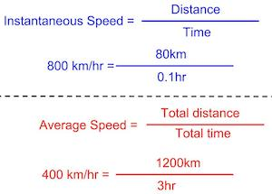

**Average Speed:** It is the ratio between the Total Distance travelled and the Total time taken for the travel (Average Speed = Total Distance / Total Time)

**Instantaneous Speed:** The speed of an object at that very particular specific instance of time.

**Uniform Speed:** When an object is travelling at a constant speed and the rate of change of distance remains the same. It doesn’t get faster or slower.

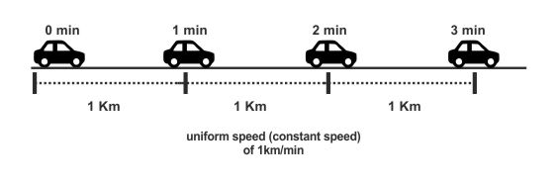

**Variable Speed:** When an object is travelling at different speeds and the rate of change of distance varies. It can get faster or slower.

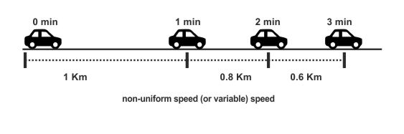

**Velocity:** It tells us how fast we are moving and is the ratio between total displacement and total time taken for the trip. It is a vector quantity. It is the rate of change of displacement

*(Velocity = Displacement / Time)*

**Average Velocity:** It is the ratio between Total Displacement travelled and the Total time taken for the travel.

*(Average Velocity = Total Displacement / Total Time)*

**Instantaneous Velocity:** The velocity of an object at that very particular specific instance of time.

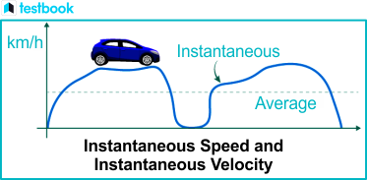

**Uniform Velocity:** When an object is travelling at a constant velocity, the rate of change of displacement remains the same and the direction doesn’t change. It doesn’t get faster or slower and travels in the same direction.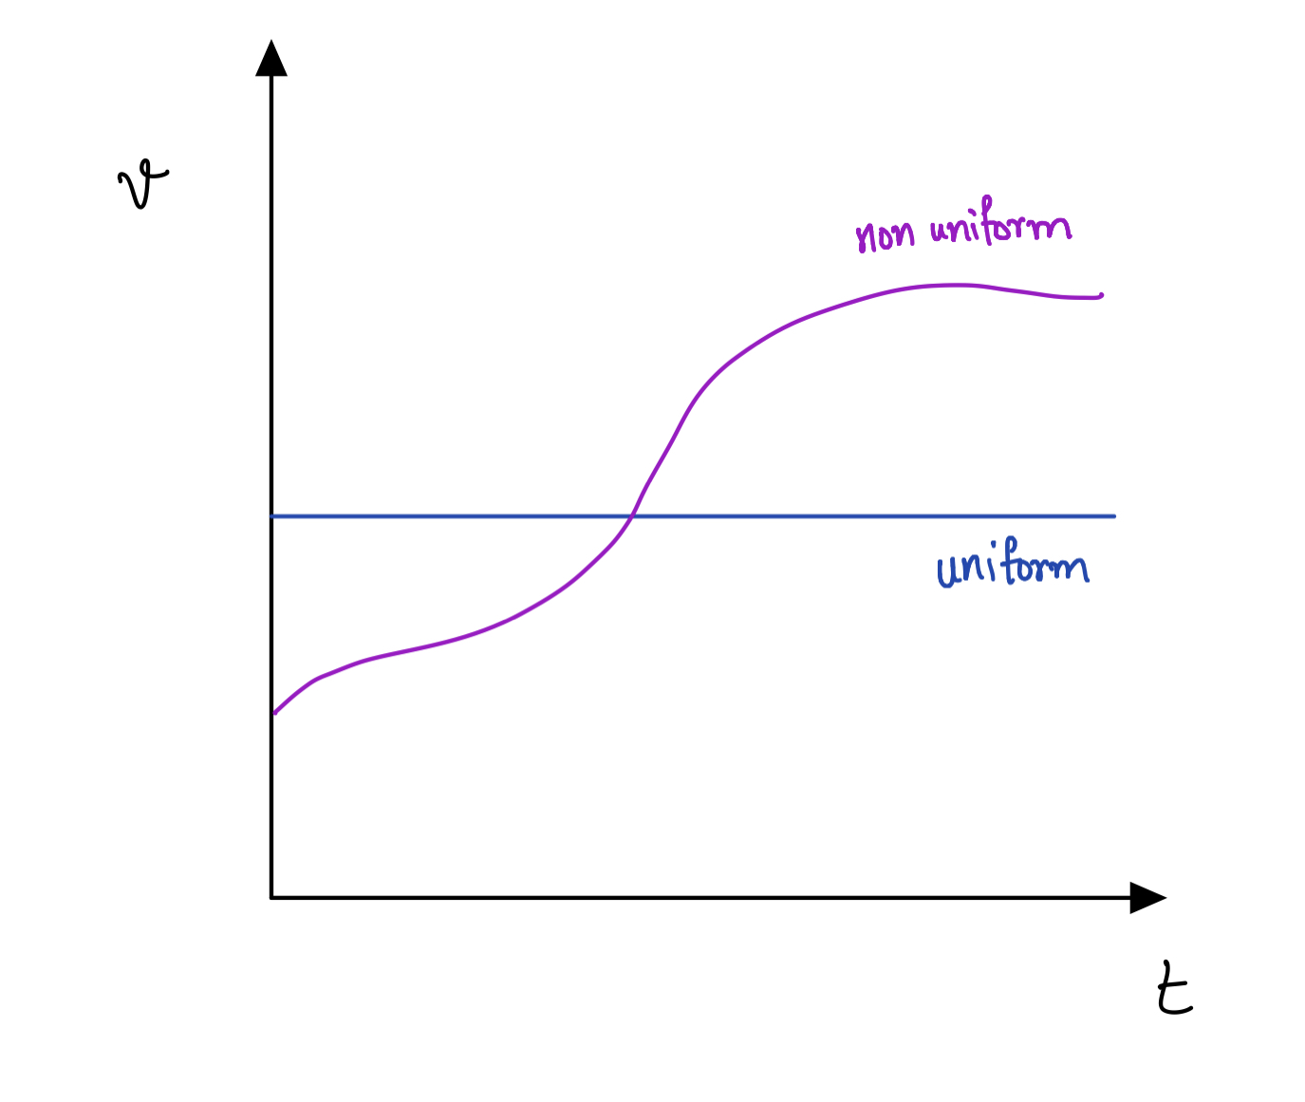

**Variable Velocity:** When an object is travelling at different velocities, the rate of change of displacement varies and the direction can change. It can get faster or slower and the direction can change.

**Acceleration:** It tells us how fast our velocity is changing and is the ratio between velocity and time taken for the travel. It is the rate of change of velocity. Vector Quantity.

*(Acceleration = Velocity / Time)*

**Deceleration:** Deceleration is negative acceleration, which means that the velocity is decreasing with time.

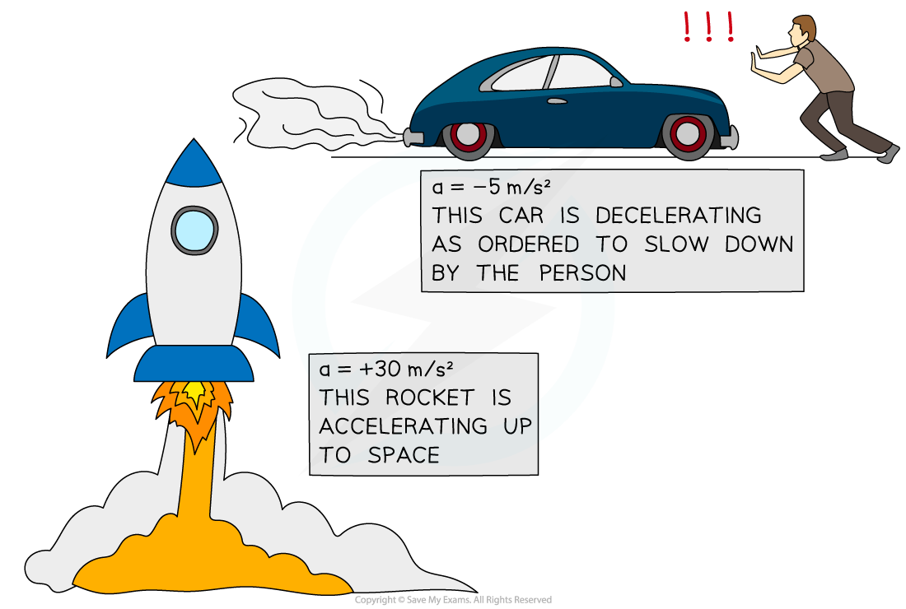

**Uniform Acceleration:** When an object is travelling at a constant acceleration, the rate of change of velocity remains the same and the direction doesn’t change. It doesn’t get faster or slower and travels in the same direction.

**Non-Uniform / Variable Acceleration:** When an object is travelling at different acceleration, the rate of change of velocity varies and the direction can change. It can get faster or slower and the direction can change.

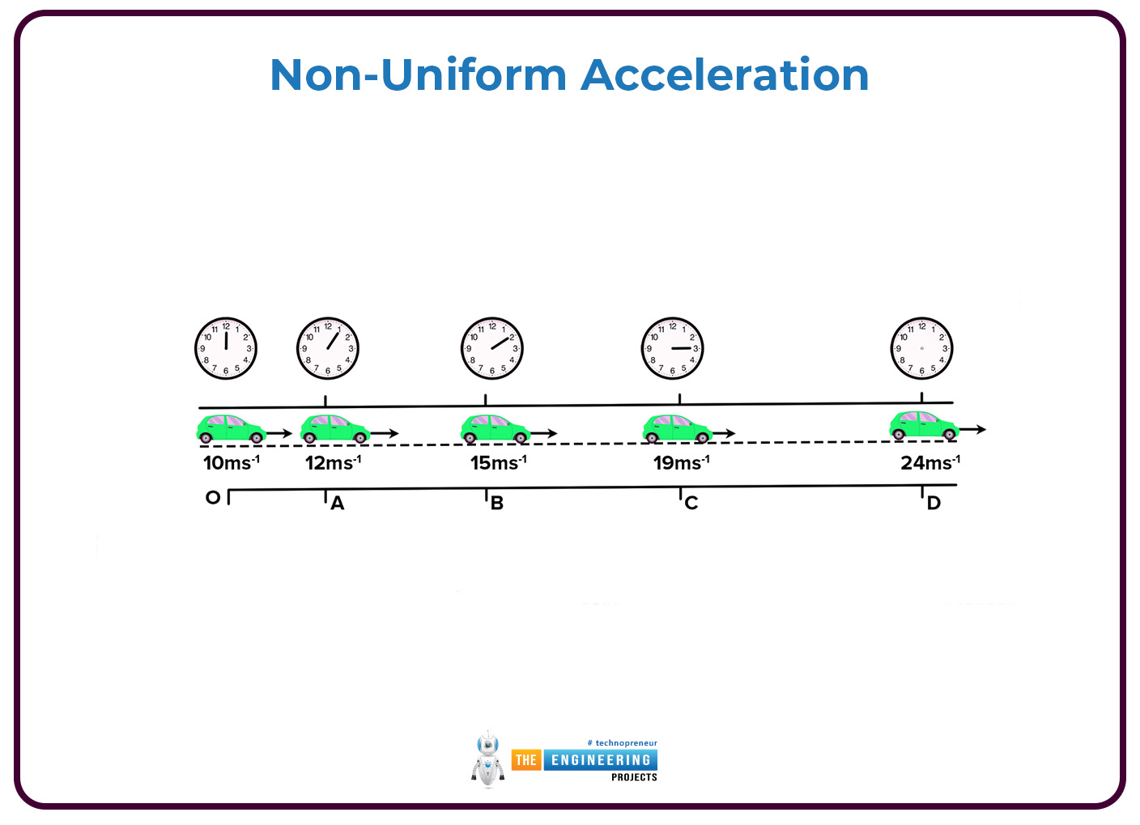

***Motion Due To Gravity:*** This is movement due to gravity which causes objects to accelerate at the rate of 9.8m/s².

-> When an object moves with gravity, e.g. being thrown downwards, the acceleration due to gravity is taken as positive, *+9.8 m/s*².

-> When an object moves against gravity, e.g. being thrown upwards, the acceleration due to gravity is taken as negative, *-9.8 m/s*².

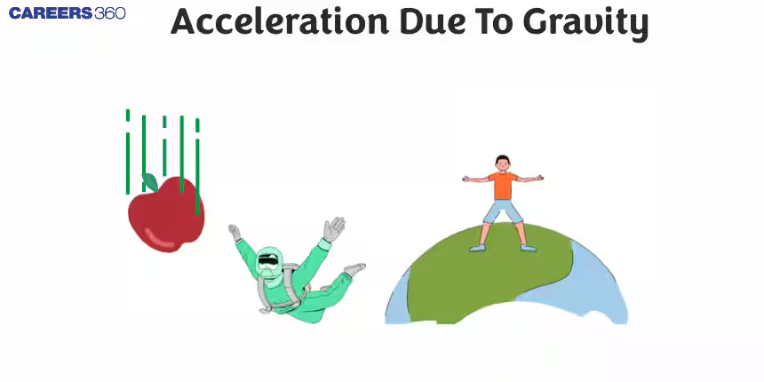

**Distance-Time Graph**

The y-value tells the distance travelled while the x-value tells the time taken to travel. The gradient(slope) of the graph is the speed.

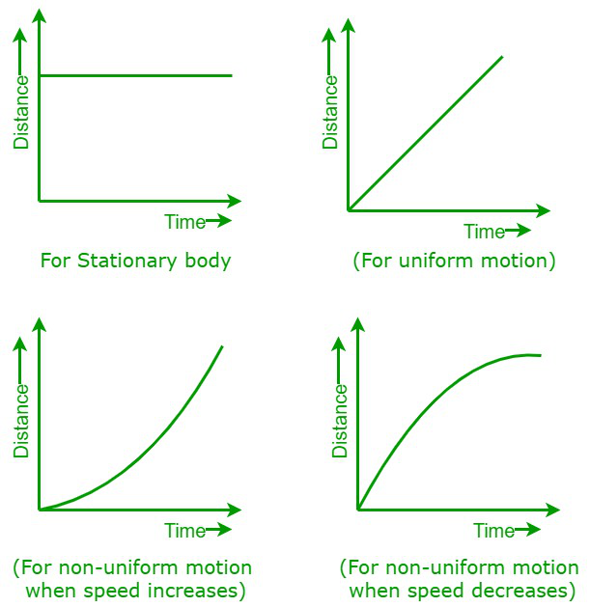

**Speed-Time Graph**

The y-value tells the speed you are travelling at while the x-value tells the time taken to travel.

* The gradient(slope) of the graph is the acceleration.
* Area under the graph / curve is equal to the distance travelled.

